Outreach 2025-26
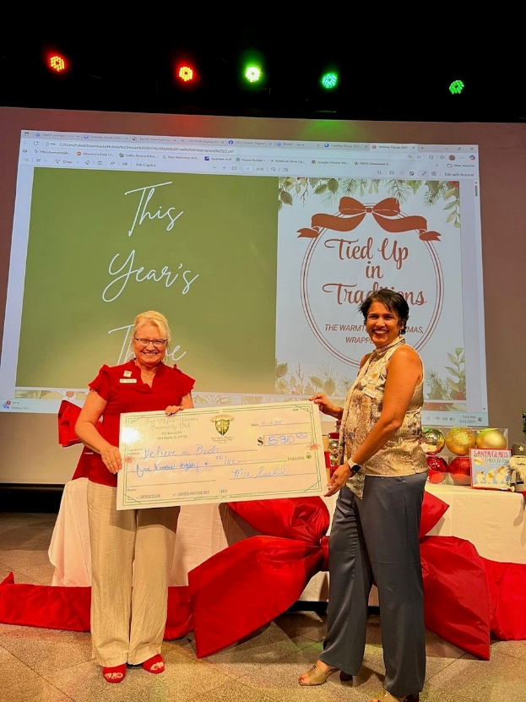
September

Believe N Books
Believenbooks.com

BelieveNBooks, Inc. is a youth-led non-profit organization with the mission of providing children with new & gently used books to expand their horizons and enhance their understanding of the world. Since we started, we have run over one hundred book drives collecting new & gently used books. We have donated over 200,000 books to 25,000 underserved children across 11 chapters. Our digital learning library program, PAGETURNER, has been distributed to over 1000 kids and the demand to participate in this program is high. We continue to add initiatives such as reading programs and free library boxes and are expanding faster than we could have imagined.

We raised $530 in which some money was used to purchase books for the Holiday House Stroll. All books from the Holiday House Stroll were donated to Believe N Books.

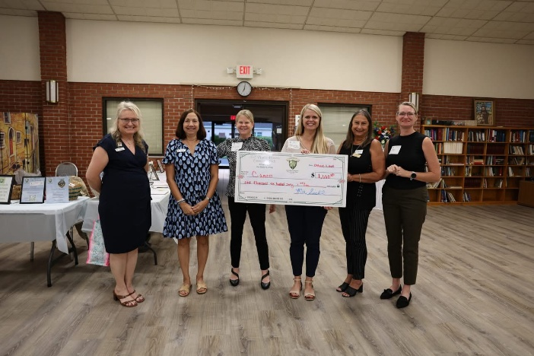
October

www.Cameoofleecounty.com

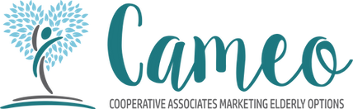
Cameo is a non-profit organization, committed to improving the lives of seniors in Southwest Florida. Their mission is to support the underserved senior population in Lee County, ensuring they have access to essential resources, services, and opportunities for a better quality of life.
$1660 raised

November
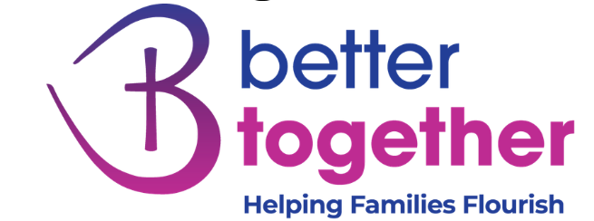
Better Together
https://bettertogetherus.org/
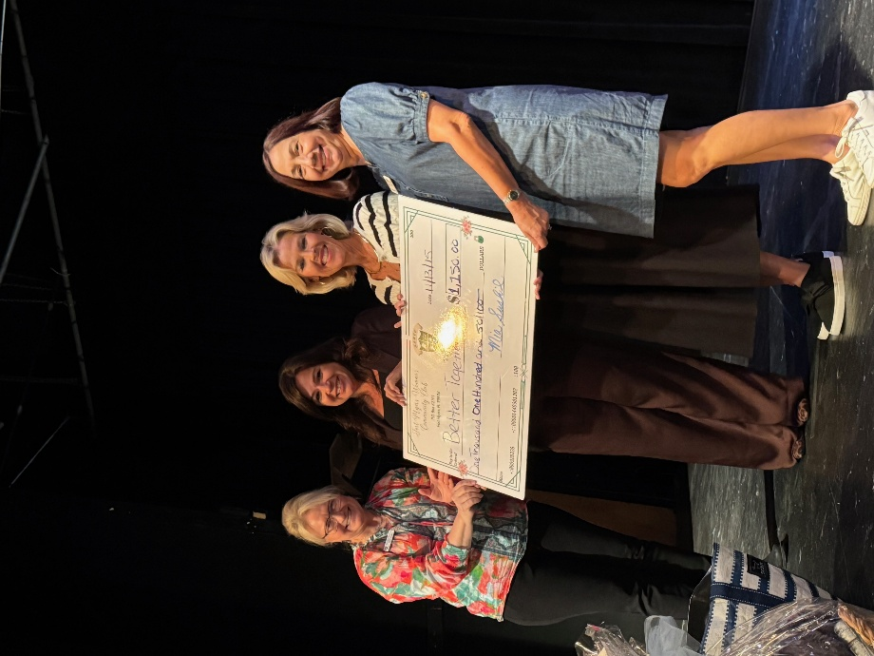
We build strong families and communities. Better Together helps families in crisis by empowering parents and surrounding them with community, work opportunities and love so that no family struggles alone ultimately preventing the need for foster care and ending government dependency.
$1150 raised

January
PACE
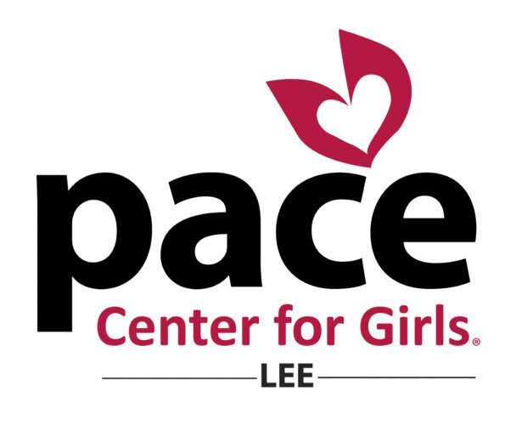
https://www.pacecenter.org/locations/florida/lee/
Pace Center for Girls provides a safe and supportive environment for
girls to build healthy relationships, plan for their future and overcome
histories of trauma. All girls, regardless of their background, deserve an opportunity to become strong, compassionate and successful women.When properly supported, all girls have the power to achieve theirvision of success, which leads to positive outcomes for themselves, their families and communities.

$2040 raised

